TOWNSVIEW SCHOOL
2021-2022 SCHOOL SUPPLY LIST: KINDERGARTEN

- 1 package of 24 Crayola pre-sharpened pencil crayons
- 1 package of 24 Crayola crayons
- 2 packages of 8 Crayola markers
- 2 packages of 12 HB pencils (Blue Staedtler Brand)
- 3 white erasers with white plastic covers ( i.e Basic brand or Staedtler brand)
- 3 Elmers Glue Sticks, 40g
- 2 Poly duo-tang report covers (plastic) - blue
- 2 Poly duo-tang report covers (plastic) -orange
- 2 Poly duo-tang report covers (plastic) -red
- 2 Hilroy Exercise Books (40 Page)
- 1 Hilroy yellow exercise books – ½ plain & ½ ruled, looks like this:
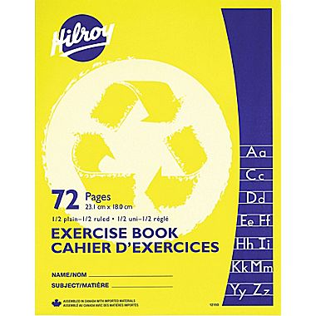
- 2 Expo Dry erase markers, blue
- 1 Fine-tip black Sharpie marker
- 2 boxes of Kleenex
- 1 box of Large Ziploc bags
- 1 package Lysol wipes (80 count)
______________________________________________________________________________

NOTES:

- Please note in addition to the school supplies, students will need a refillable water bottle, lunch box, book bag and indoor sneakers with non-marking soles for Phys. Ed and the classroom. (Please put your child’s name on each of these items, it is easier to return them when they become lost).

- Parents have the option to purchase a school pack, or purchase the school supplies on their own.

- If you wish to buy a school pack, payment can be made by cash, by cheque (cheques made payable to Townsview School using School Cash Online. https://district.schoolcashonline.com/. When you pay by school cash online, please print your transaction receipt for your records. Our preferred method of payment would be by School Cash Online.

- Please note that all items being purchased at the school will be approximately 4% (plus tax) higher due to the ASD-W convenience fee. The cost to purchase the school supply pack will be $50.00 plus the 4% (plus tax) convenience fee.

- This option to purchase a school supply pack for your child will only be available up until Friday, June 25, 2021. After this dateline has passed – we will be asking parents/guardians to purchase their child’s school supplies themselves. Thank you.

